

**Task Level: Advanced**

**Crime Rate Analysis in 2022 across India's States and Union Territories: A Comprehensive Data-Driven Study**

**By Aishwarya Kande**

**Data Analytics Intern at CodEvo Solutions**

**Id: xl7uklin**

**Date: 20/09/2024**

**CONTENTS**

|  |  |  |
| --- | --- | --- |
| S. No | Content | Page no. |
| 1.  2.  3.  4.  5.  6. | About this Report  Methodology  Analytical Tools and Techniques  Visualization and Findings  Recommendations  Conclusion | 3  4  5  6-7  8  9 |

**ABOUT THIS REPORT**

**Overview**

This Power BI dashboard provides a detailed analysis of crime statistics across different states and union territories (UTs) in India. The primary goal of this analysis is to present a comprehensive breakdown of various crime types and highlight the distribution trends in major states. It serves as a valuable tool for law enforcement agencies, policymakers, and the public to understand the crime dynamics across the country.

**Key Components**

The dashboard provides a comprehensive analysis of crime distribution across states and types in India. It highlights that Uttar Pradesh, Bihar, and Maharashtra have the highest counts of violent crimes, while Gujarat, Telangana, and Assam report fewer incidents. A scatter plot shows the relationship between murders and rapes, with larger bubbles indicating higher crime rates in regions like Uttar Pradesh and Maharashtra. A pie chart reveals that Kidnapping and Abduction constitute 44.7% of total crimes, followed by Murder, Rape, and Rioting. A stacked bar chart compares different crimes across states, emphasizing significant issues in Uttar Pradesh, Bihar, Maharashtra, and Madhya Pradesh. Lastly, a detailed table ranks states by various crimes, aiding in policy decision-making.

**Insights**

States like Uttar Pradesh, Bihar, and Maharashtra report high levels of violent crimes such as Murder, Rape, and Kidnapping, likely due to dense populations and socio-economic factors. Kidnapping and Abduction are particularly high, indicating a need for better enforcement and protection, especially for women and children. While Murder and Rape are less frequent overall, they are still common in states like Uttar Pradesh, Maharashtra, and Madhya Pradesh.

**METHODOLOGY**

Data Collection:

Data from the Open Government Data (OGD) platform for 2022 includes crime statistics across various categories for all states and union territories.

Data Cleaning and Preparation:

The dataset was cleaned in Excel, addressing missing data, removing duplicates, and normalizing for consistency.

Data Organization:

Cleaned data was structured into tables with rows for incidents and columns for variables like state and crime type, divided into sheets for clarity and validated for accuracy.

Analytical Tools and Techniques:

Analysis was conducted using Microsoft Excel and Power BI.

* Descriptive Analysis: Calculated basic statistics to understand key trends and variations.
* Trend Analysis: Examined temporal patterns to spot significant changes in crime rates.
* Comparative Analysis: Compared crime rates across regions to identify high and low crime areas.

Visualization:

Visualizations were created to clearly present the findings, including bar charts, Scatter chart, Pie chart. Interactive dashboards allowed for dynamic data exploration, ensuring insights were accessible and actionable.

**ANALYTICAL TOOLS AND TECHNIQUES**

This report used Microsoft Excel and Power BI for data analysis and visualization, each contributing uniquely to the comprehensive analysis of crime rates across India in 2022.

Microsoft Excel

* Data Cleaning: Excel was used to clean the raw data, handle missing values, remove duplicates, and normalize the dataset for consistency.
* Data Organization: Excel’s tabular structure and pivot tables were utilized to organize and categorize crime data by type, region, and other variables, making it easier to analyse.
* Preliminary Analysis: Basic statistical functions (e.g., averages, medians) were applied to gain initial insights into trends and variations across regions.
* Pivot Tables and Charts: Excel’s pivot tables and basic charts facilitated the summarization and preliminary visualization of data.

Power BI

* Interactive Dashboards: Power BI enabled the creation of interactive dashboards that allowed for in-depth exploration of the data, enhancing the ability to derive actionable insights.
* Advanced Visualizations: Various visualization options, including bar charts, Scatter chart, Pie chart, were used to clearly represent complex data and trends.
* Trend Analysis: Temporal visualizations tracked changes in crime rates over the year, highlighting significant trends and anomalies.
* Data Integration: Power BI’s capabilities allowed for deeper analysis, such as calculating crime rates per capita and exploring correlations between crime types.
* Report Generation: The findings were compiled into a visually appealing and easily shareable report, ensuring effective communication of insights.

**VISUALIZATION AND FINDINGS**

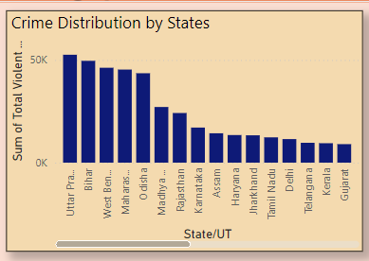

1. Uttar Pradesh, Bihar, and Maharashtra show the highest counts of violent crimes across all states and union territories. The states further down the list show comparatively lower crime counts.

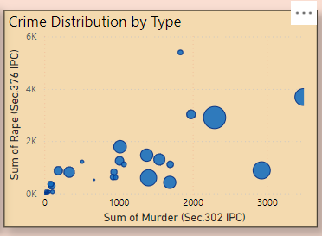2. There is a strong correlation between higher counts of murders (Sec. 302 IPC) and rapes (Sec. 376 IPC), with larger bubbles representing states with high crime occurrences in both categories.

3. Kidnapping and abduction (44.77%) and murder (11.8%) constitute the largest proportions of crimes, with rape and rioting also being significant contributors.

4. Uttar Pradesh consistently tops in all major crime categories, including murder, rape, and robbery. The distribution suggests varying levels of crimes across different states, with some specializing in particular crime types.

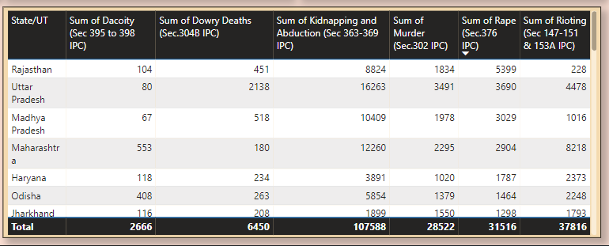

5. The table provides a clear view of the breakdown of various crimes by state/UT. For example, Rajasthan has a significantly high number of kidnapping and abduction cases, while Uttar Pradesh leads in dowry deaths and murders.

**Recommendations**

* Special focus on top three states (Uttar Pradesh, Bihar, and Maharashtra) for crime prevention initiatives and resource allocation. Crime mitigation strategies could be prioritized based on the population density, crime types, and region-specific socio-economic factors.
* States with high occurrences of both crimes, such as Uttar Pradesh and Maharashtra, need targeted intervention programs. This may include better law enforcement practices, awareness campaigns, and community involvement.
* The focus of policy reforms and interventions should prioritize the top crime types. Kidnapping and abduction, in particular, needs immediate attention, with preventive actions like community policing, surveillance, and public safety measures.
* High-crime states should adopt state-specific strategies tailored to the types of crimes they are dealing with most frequently. For example, Uttar Pradesh should focus on reducing both violent crimes like murder and rape.
* This data could be used to analyse trends over time and support predictive analytics. Law enforcement agencies should focus on data-driven decisions, allocating resources where the crime rates are highest for each category.
* **Enhanced Surveillance and Policing**: The states with the highest crime rates, such as Uttar Pradesh and Bihar, need more active law enforcement and public safety measures.
* **Awareness Campaigns**: Focus on public education and crime awareness campaigns targeting crimes like kidnapping, rape, and murder.
* **Data-Driven Policies**: Utilize crime data analytics to tailor crime-prevention strategies according to the specific crime type prevalent in each state.

**CONCLUSION**

* The dashboard highlights a worrying trend of violent crimes in a few key states, with significant correlations between different types of violent crimes. A multifaceted approach that combines strong law enforcement, public awareness, and state-specific intervention programs is essential to reduce crime rates across India.
* High crime rates in populous states suggest a need for greater law enforcement presence and crime deterrence measures.
* High correlation between major violent crimes indicates a pattern that could be analysed further to understand common underlying causes like social unrest, economic inequality, or law enforcement challenges.
* The pie chart helps prioritize law enforcement efforts by highlighting crime types with the most occurrences, which are critical to address for reducing overall crime rates.
* A broad approach for crime control will be less effective. Instead, a more crime-type-focused approach is necessary for states to address their specific crime issues effectively.
* The detailed breakdown can assist policymakers in creating a customized crime prevention and intervention strategy for each state, focusing on high-priority crimes.